Midwinter RoA Enhancements

Last updated on: 7th February 2023

Contents
Introduction 2
Changes in ‘Recommendations’ section 2
Changes in ‘Costs’ section 4
Other changes 6

Introduction
Midwinter has made updates within the Midwinter RoA template v10. The new minicodes added in the template will populate based on the module used for analysis i.e. TPA or Product Comparison. This guide will explain the changes that have been made within the template.

Changes in ‘Recommendations’ section
- The existing investment option table for non-superannuation investment platforms has been added under the ‘Redeem your funds’ recommendation for primary client, spouse and joint owners. The screenshot below shows where the table will populate from in AdviceOS: (highlighted in yellow):
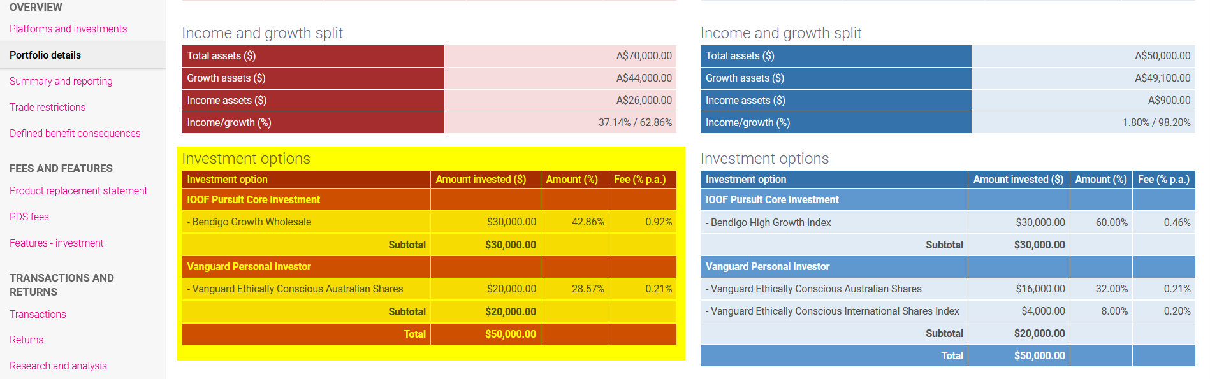
- The recommended investment option table for non-superannuation investment platforms has been added under the ‘Invest your additional funds’ recommendation for primary client, spouse and joint owners. The screenshot below shows where the table will populate from in AdviceOS: (highlighted in yellow):
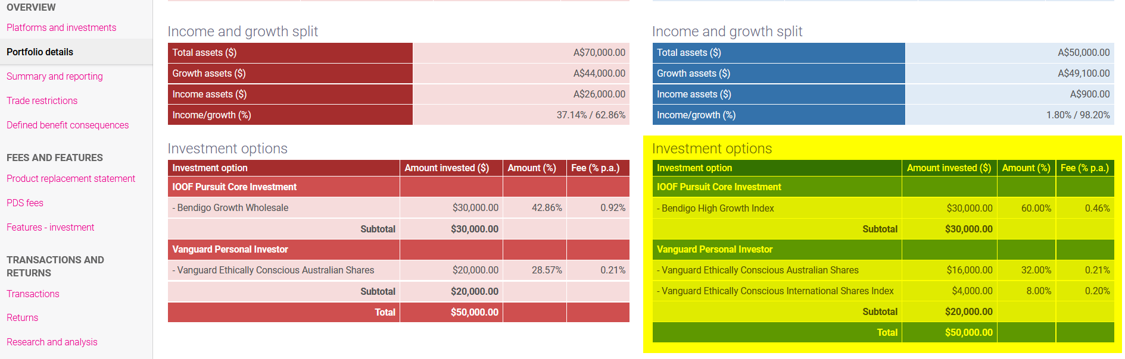

- The recommended regular investment contribution table has been added under the ‘Review your regular savings plan’ recommendation for primary client, spouse and joint owners. The screenshot below shows where the text will populate from in AdviceOS (highlighted in yellow):
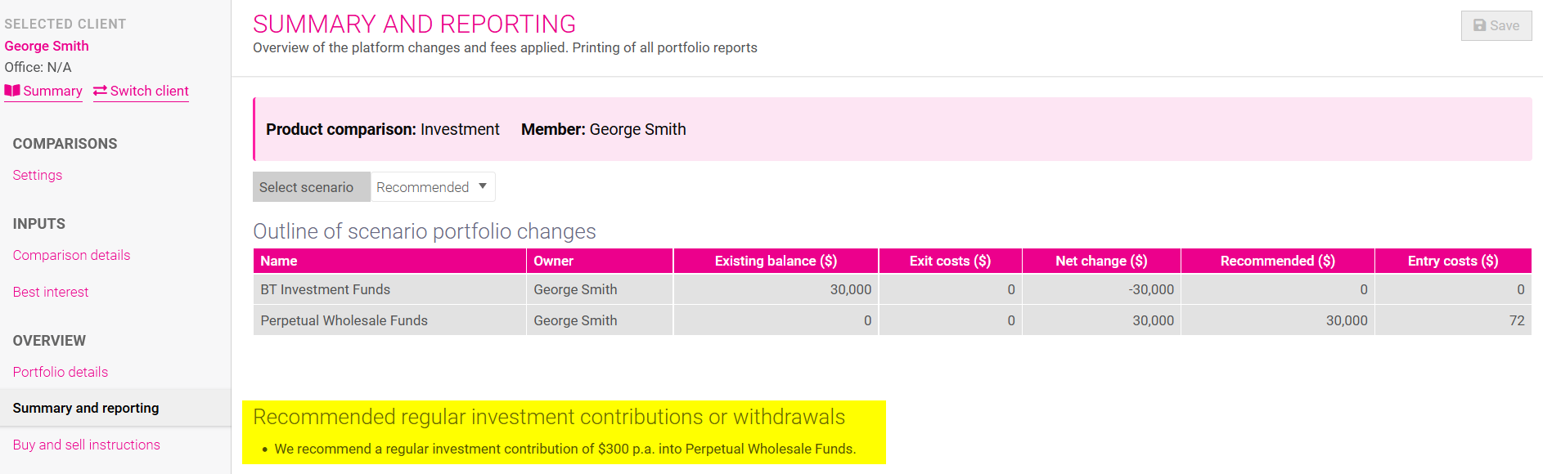
- The 'Strategic Asset Allocation' section has been added before 'Financial outcome' section. This section will show the client’s overall existing and recommended strategic asset allocation. The relevant tables and charts have been automated to appear in the report when the following recommendations are chosen in Planbuilder:
- Redeem your funds
- Invest your additional funds
- Rebalance your portfolio

The screenshot below shows where the tables and charts will populate from in AdviceOS:
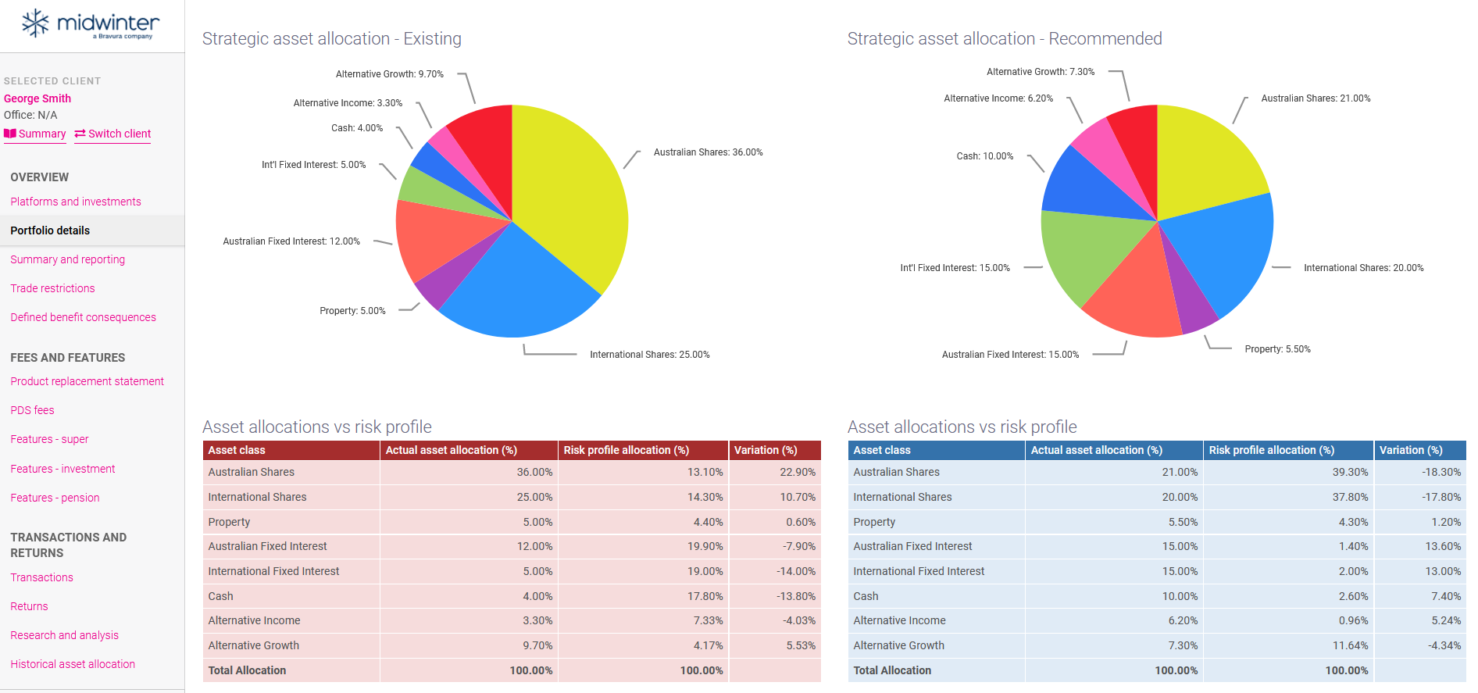

Changes in ‘Costs’ section
- The ‘Costs’ section has been renamed to ‘Disclosure of fees’.
- We have enhanced the tables under ‘Redeem funds’ and ‘Invest your additional funds’, by adding the ‘buy and sell instructions’ table in the ‘Disclosure of fees’ section. The screenshot below shows where the information comes from in AdviceOS:
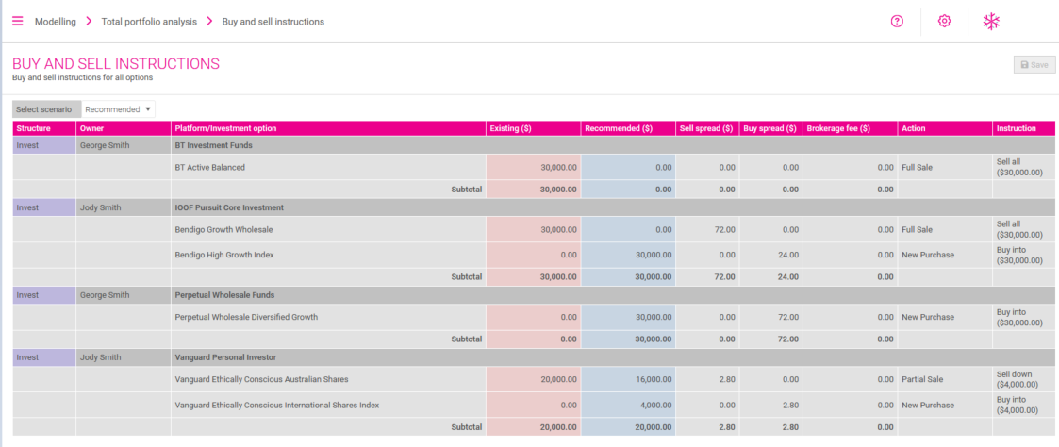

- The layout of the ‘Change in management fees’ table has been changed to fit the data for all owners in one table. Screenshots are shown below to show the difference in the layout before and after:

Before:
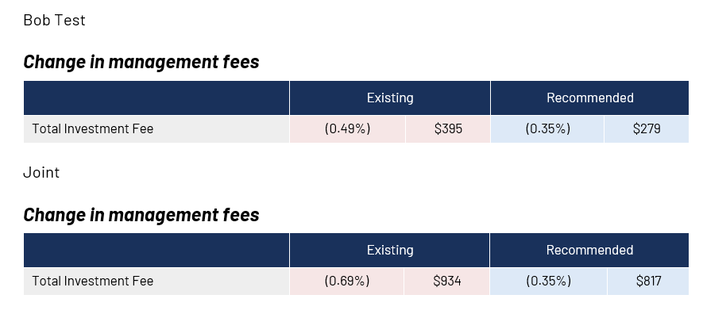
After:
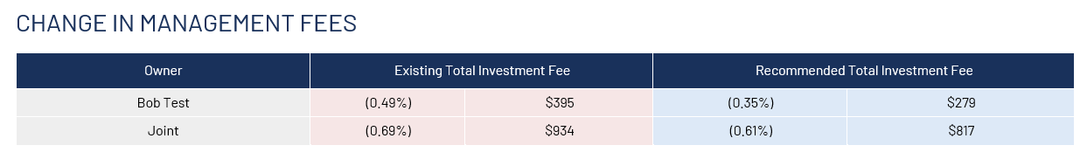

Other changes
- The ‘Warning’ section has been replaced with the ‘Authority to proceed’ section.
- The adviser’s authorised representative number has been added on the second page, under the adviser’s name and qualification details. An example of how this will appear in the generated report is shown in the screenshot below (highlighted in yellow):
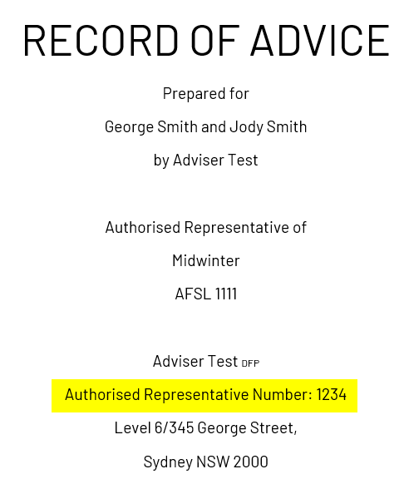
- The ‘Basis of advice’ section has been replaced with the ‘Summary of our advice’ section. This information will flow from Planbuilder as shown in the screenshot below (highlighted in yellow):
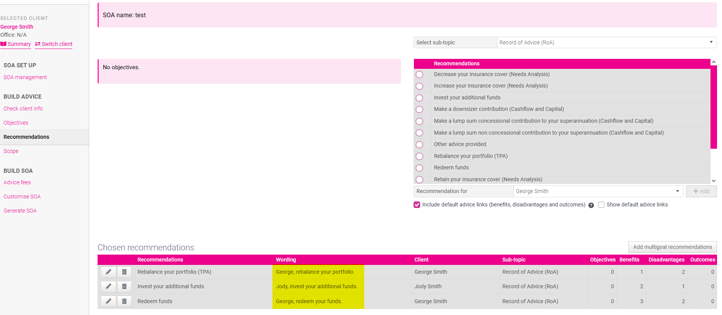

- ‘Outcomes of our advice’ has been added after the ‘Summary of our advice’ section. Outcomes have been added to the Midwinter advice text library within the ‘Record of Advice (RoA)’ sub topic. The outcomes will flow from Planbuilder as shown in the screenshot below (highlighted in yellow):
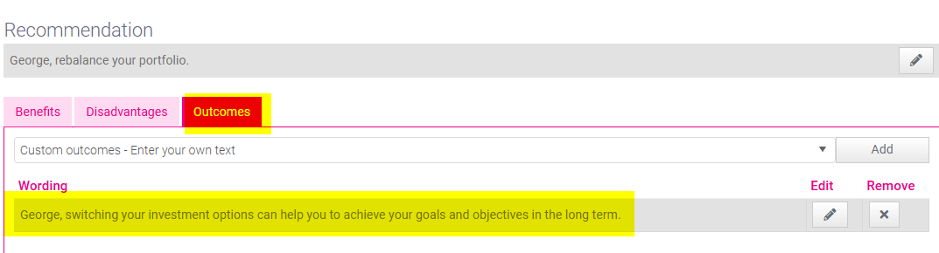



Level 6/345 George Street, Sydney NSW 2000

info@midwinter.com.au

1300 882 938

Midwinter Financial Services

