Frequently asked questions
- How do I upload custom templates under my practice or dealer group?
- Home – Settings – User Documents and Templates – User Templates.
- Under “Template Owner”, locate your practice – Click on Upload (Cloud icon with upward arrow).
- Select the template from your desktop.
- Enter a description and select the correct plan type. If the document is for a single client, make sure you select “Is Single”.
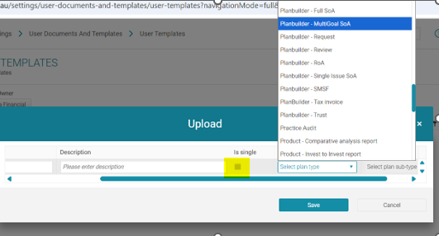

- Click Save

- How do I replace an existing template?
- Locate your template under: Home – Settings – User Documents and Templates – User Templates.
- Click on the 3 dots icon and select “Replace”:
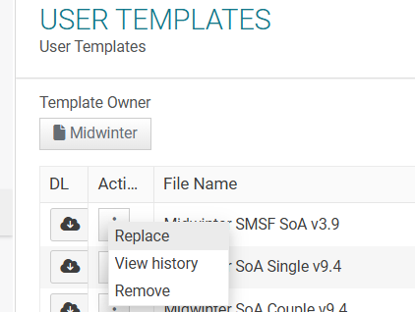

- How do I customize my own templates?
- Locate your template under: Home – Settings – User Documents and Templates – User Templates.
- Click on the Cloud icon with the downward arrow to download your template.
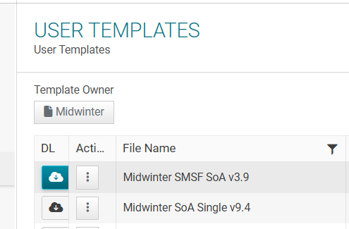

- What areas can I update inside my template?
- Update static text such as add text and add additional dot points.
- Add mini codes found in the Knowledge Base: https://help.midwinter.com.au/portal/en/kb/articles/user-documents-and-templates#How_to_use_general_____customisation_tools
- Update and add in any content controls (Training videos can be located in the knowledge base link above).

- I’ve added a mini code into a table, but it is not populating anything, why?
- Table mini codes are different to standard mini codes. If you add a mini code from the mini code excel spreadsheet into a table it will not work. For any customization to tables or additions of new mini codes, we will need to contact the dev team to create the mini code. Please send your request to the Midwinter team for assistance.

- I want to create my own advice text in AOS, and I don’t want to use the midwinter text. Where do I create this?
- Go to Settings> Statement of Advice > Advice text.
- Select Owner Level (Practice or Dealer group) depending on which one you belong to.
- Select Edit then click on Add Wording.
- Select the Type of text you want to amend from the list below:
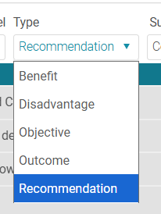
- Select the relevant Sub-Topic where you would like the text to be added.
- Edit text and click “Save”.

- My edit button is greyed out; how do I fix this?
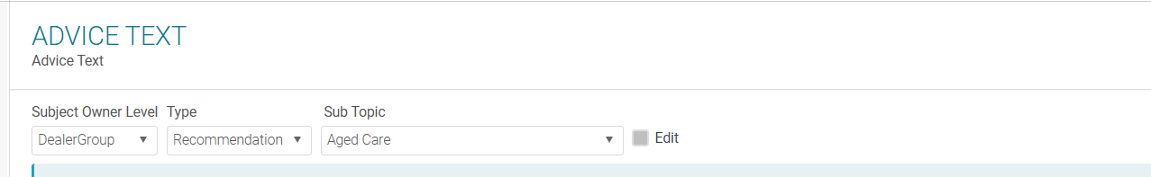
- If your edit button is greyed out, you will need to request permission to edit text from the Midwinter team.

- I’m from a practice and would like to amend text for the dealer group, is this allowed?
- No, a user from a practice can only amend text for the practice. If you want to amend text at the dealer group level, the request will have to come from the dealer group.

- I’m not happy with the Midwinter wording and would like to amend the text, how do I do this?
- You will need to send a request to Midwinter team to copy the Midwinter wording to either the Practice Level or Dealer Group level depending on which level you belong to.
- Once the text is copied over, you will be able to see and amend the text. Ensure you have permission to press “edit”, if not, please send a request to the Midwinter team.

- I tried to run an SOA/ROA and I’m getting blank recommendations and can’t see any Midwinter text, why?
- Under SOA management make sure wording level: Midwinter is selected per the screenshot below:
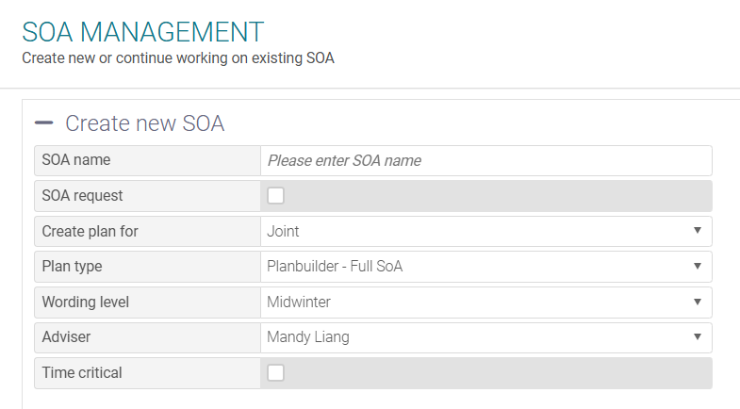
- If you would like the text level to be defaulted to Midwinter wording instead of changing this every time, you may send a request to Midwinter team to change the default wording level.

- I’ve added my own text into advice text area, but when I print my SOA/ROA I only see midwinter wording and I can’t see my own text, why?
- Under SOA management, ensure the correct wording level is selected. If you have added the text under Dealer Group then select “Dealer Group”, if you have added the wording to Practice then select “Practice”.
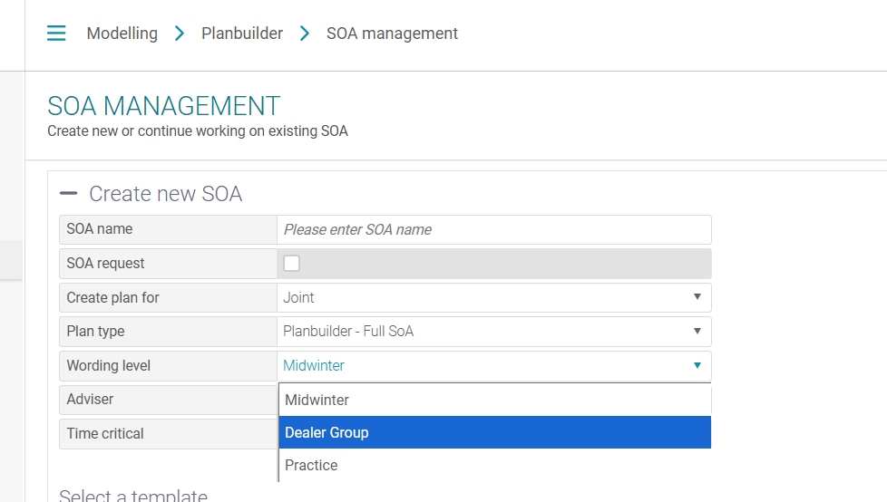

- I opened a SOA document by Midwinter, and I can’t see or amend any content controls, why?
- You need to ensure you have the “add on” for Developer mode selected inside Word.
- Select “Design Mode” to see the content controls.
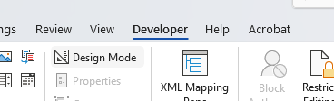

- I’ve added in content controls into my customized document and loaded the document into AOS, however I can’t see anything being ticked when I go to “customize SOA” within Plan Builder, why?
- To have the selection automatically ticked you will need to go Settings – User Documents and Templates – User Template Links.
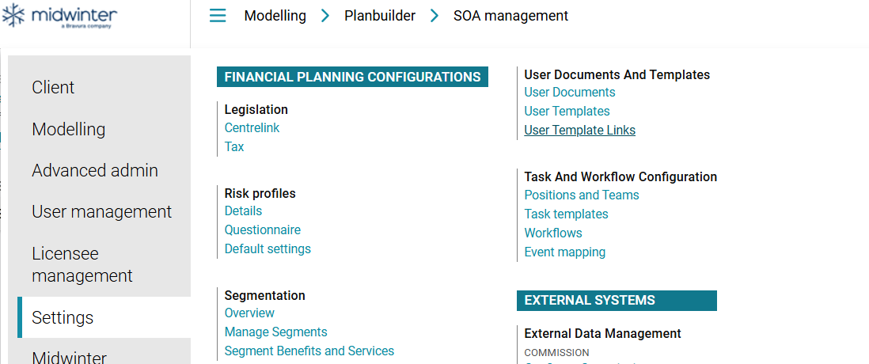
- Select the Template Owner that applies and pick the correct document. You will need to tick the Available Links manually and save before it appears in the customize SOA section of Plan Builder.
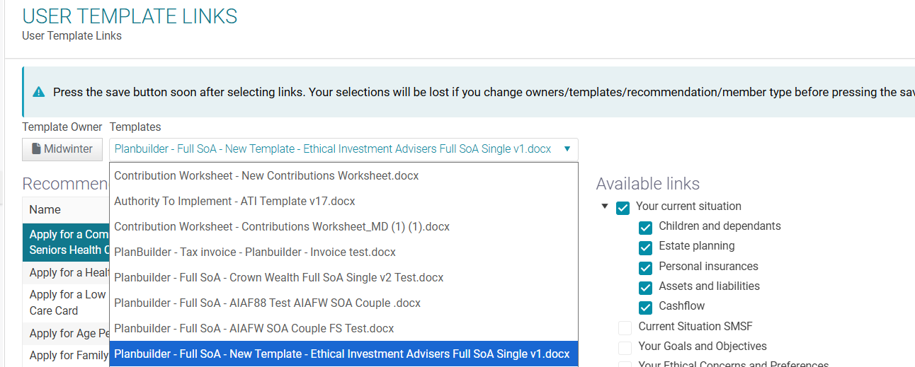

- When I merge my SOA/ROA document, there are areas where it says No Data Available, how do I fix that?
- You will need to make sure the fields have information filled in within AOS.

- If I need to raise a template question to the template team, what information do I need to provide?
- Name of the user and practice name
- Provide the template you are using? We need to know if it is a midwinter template or your own template.
- Screenshot which table or code is not working.

- I have a custom template for the Templating Team to debug, what is the process?
- The template team will need a minimum of 2 hours to investigate the template and evaluate what the error is. This will be chargeable work.
- If the debugging takes longer, it will be charged accordingly.

- I would like to request a quote from the template team, what information do I need to provide?
- What sort of customization are you after? For e.g.: additional mini codes that currently don’t exist or additional pages to be coded?
- You will need to provide a requirement document of where you would like the new information inserted inside the template.
- Do you want to just add static text, or does the text have some conditioning? For e.g.: the text should only appear if an insurance strategy is selected etc.
- Do you need additional strategies created? If so, we need to know the number of new strategies you are adding and how they are categorized.
- Are you creating both single and couple documents?

- Where do I find training material on templates and training videos?
- Refer to this article in the knowledge base: https://help.midwinter.com.au/portal/en/kb/articles/user-documents-and-templates#How_to_use_general_____customisation_tools

